BEEE Evaluation report

Name – Joedeep Singh

UID – 19BCS6157

AIML-2(B)

Q28 - **Design a system for car stereo systems such that whenever the increase volume button is pressed, a Green Light is emitted for 20 ms & whenever the decrease volume button is pressed, a Red Light is emitted for 40 ms.**

**Circuit Diagram :**

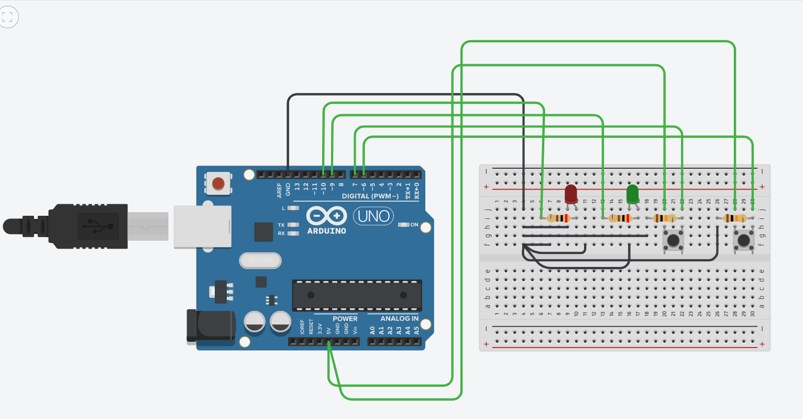

**Theory :**

Concepts Used – Main principle is the use of arduino and breadboard. A breadboard is connected with arduino, and the breadboard has two buttons and two LEDs. When ‘increase volume’ button is pressed, green LED glows and when ‘decrease volume’ button is pressed, red LED glows. The buttons should also be connected to resistors of high resistance, which are connected to ground, so that when switch is off, no current flows in the input pins.

Learning and Observation –

1. Learned to use arduino and breadboard.
2. Learned the use of buttons to turn on LEDs and how the buttons are connected to arduino.
3. Observed the use of resistors with LEDs and switches.
4. Observed the glowing of LED when button is pressed.

**Problems and Troubleshooting :**

1. LEDs may fuse due to excess voltage. To avoid this, we added resistors with LEDs so LED does not get high voltage.
2. Sometimes even if the switch is off, the input pins may get induced with small voltages due to atmospheric magnetic field, to avoid this resistors of high resistance are also added with buttons. The resistors are then connected to ground.
3. If the arduino is not working correctly then it may be connected in the wrong port of the computer. Connect arduino in the correct port and make sure that port is selected in arduino IDE.

**Precautions :**

1. All the connections should be tight and correct.
2. Check the connectivity of wires before using. The wires should not be broken from inside.
3. Resistors should be connected to LEDs to prevent the LEDs from getting fused.
4. The bigger terminal(+ve) of LED should be connected to digital pin on the arduino and the smaller terminal(-ve) should be connected to ground.
5. Add resistors with buttons to avoid induced voltage in input pins.

**Learning Outcomes :**

1. Understood the working of arduino and breadboard .
2. Understood how to use buttons to glow LEDs.
3. Learned the use of resistors with LEDs and buttons.